
SAFETY DATA SHEET
Verto Vytrex
SECTION 1: Identification of the substance/mixture and of the company/undertaking
1.1. Product identifier
Product name Verto Vytrex

1.2. Relevant identified uses of the substance or mixture and uses advised against
Identified uses Cleaning agent. Disinfectant.
Uses advised against Do not use for personal cleansing.

1.3. Details of the supplier of the safety data sheet
Supplier Contact person | Parc Global  2 Whitehall Point  Whitehall Road  Leeds  LS12 4RZ  +44 (0)113 220 4080 info@parcglobal.com  For content of safety data sheet: info@parcglobal.com

1.4. Emergency telephone number
Emergency telephone +44 (0)113 220 4080
National emergency telephone For the emergency services - the ambulance, police and fire services - Tel: 999 / number When you need medical advice or treatment but it is not an emergency - Tel: 111
SECTION 2: Hazards identification

2.1. Classification of the substance or mixture Classification (EC 1272/2008)
Physical hazards | Not Classified
Health hazards | Skin Irrit. 2 - H315 Eye Dam. 1 - H318
Environmental hazards | Aquatic Acute 1 - H400 Aquatic Chronic 2 - H411

2.2. Label elements
Hazard pictograms
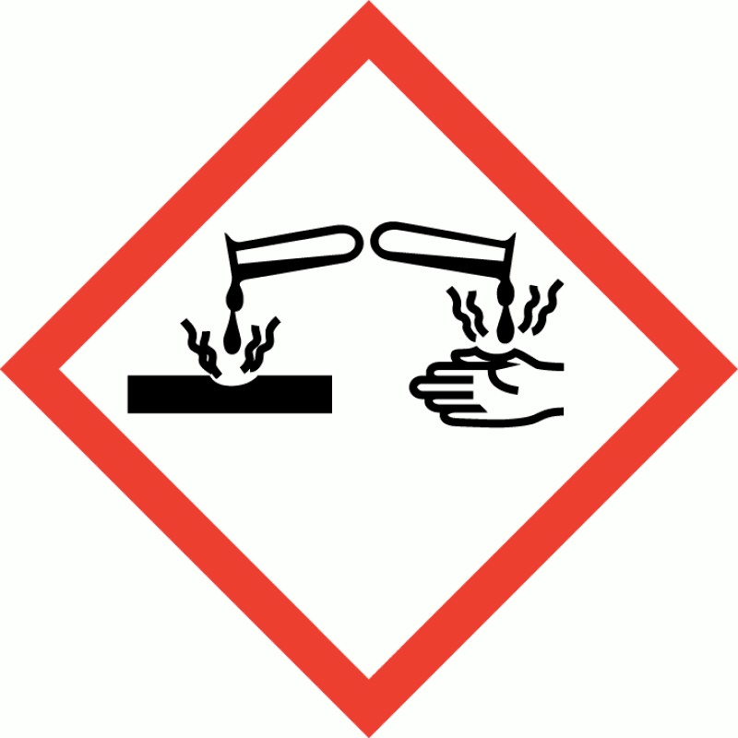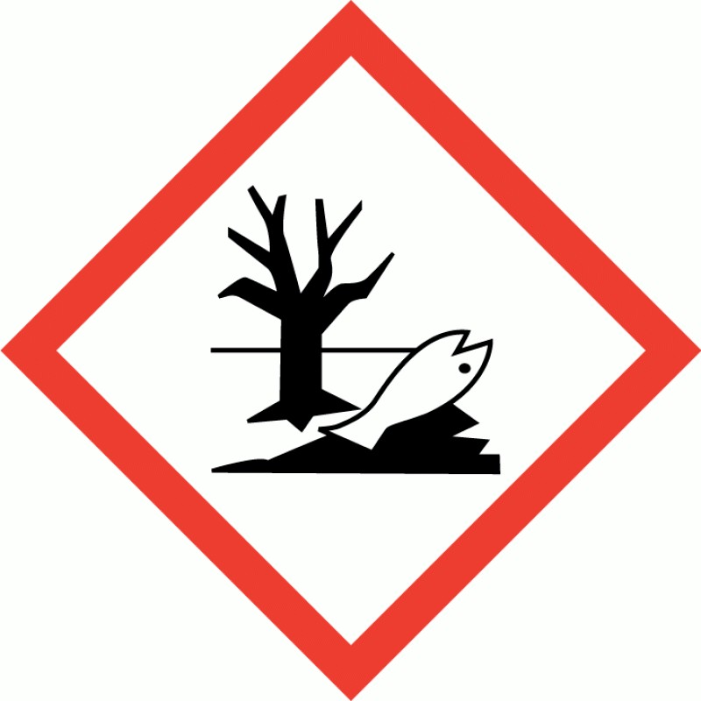
Signal word  Hazard statements  Precautionary statements  Contains  2.3. Other hazards  Other hazards | Danger  H315 Causes skin irritation.  H318 Causes serious eye damage.  H400 Very toxic to aquatic life.  H411 Toxic to aquatic life with long lasting effects.  P102 Keep out of reach of children.  P262 Do not get in eyes, on skin, or on clothing.  P264 Wash contaminated skin thoroughly after handling.  P305+P351+P338 IF IN EYES: Rinse cautiously with water for several minutes. Remove contact lenses, if present and easy to do. Continue rinsing.  P337+P313 If eye irritation persists: Get medical advice/ attention.  P501 Dispose of contents/ container in accordance with local regulations.  N-(3-aminopropyl)-N-dodecylpropane-1,3-diamine  None known
SECTION 3: Composition/information on ingredients

3.2. Mixtures
N-(3-aminopropyl)-N-dodecylpropane-1,3-diamine  CAS number: 2372-82-9 EC number: 219-145-8 |  | 1-5%
M factor (Acute) = 10 | M factor (Chronic) = 1
Classification
Acute Tox. 3 - H301
Skin Corr. 1B - H314
Eye Dam. 1 - H318
STOT RE 2 - H373
Aquatic Acute 1 - H400
Aquatic Chronic 1 - H410
Alcohols, C9-11 ethoxylated, 6-8 EO |  | <1%
CAS number: 68439-46-3 | EC number: 614-482-0
Classification
Acute Tox. 4 - H302
Eye Dam. 1 - H318
The full text for all hazard statements is displayed in Section 16.
SECTION 4: First aid measures

4.1. Description of first aid measures
Inhalation | Move affected person to fresh air at once. Rinse nose and mouth with water. Get medical attention if any discomfort continues.
Ingestion | Never give anything by mouth to an unconscious person. Do not induce vomiting. Rinse mouth thoroughly with water. Get medical attention if any discomfort continues.
Skin contact | Rinse immediately with plenty of water. Remove contaminated clothing. Get medical attention if irritation persists after washing.
Eye contact Rinse immediately with plenty of water. Remove any contact lenses and open eyelids wide
apart. Continue to rinse for at least 15 minutes. Get medical attention if irritation persists after washing. Show this Safety Data Sheet to the medical personnel.

4.2. Most important symptoms and effects, both acute and delayed
Skin contact Prolonged contact may cause redness, irritation and dry skin.
Eye contact May cause temporary eye irritation.
4.3. Indication of any immediate medical attention and special treatment needed Notes for the doctor No specific recommendations.
SECTION 5: Firefighting measures

5.1. Extinguishing media
Suitable extinguishing media The product is not flammable. Use fire-extinguishing media suitable for the surrounding fire. Foam, carbon dioxide or dry powder.

5.2. Special hazards arising from the substance or mixture
Hazardous combustion Thermal decomposition or combustion products may include the following substances: Oxides products of carbon. Toxic gases or vapours.

5.3. Advice for firefighters
Protective actions during Control run-off water by containing and keeping it out of sewers and watercourses. firefighting
Special protective equipment Wear positive-pressure self-contained breathing apparatus (SCBA) and appropriate protective for firefighters clothing.
SECTION 6: Accidental release measures
6.1. Personal precautions, protective equipment and emergency procedures
Personal precautions For personal protection, see Section 8. Contaminated surfaces will be extremely slippery.

6.2. Environmental precautions
Environmental precautions Collect and dispose of spillage as indicated in Section 13. Do not discharge into drains or watercourses or onto the ground.

6.3. Methods and material for containment and cleaning up
Methods for cleaning up Stop leak if safe to do so. Absorb in vermiculite, dry sand or earth and place into containers. Flush contaminated area with plenty of water. Avoid the spillage or runoff entering drains, sewers or watercourses.

6.4. Reference to other sections
Reference to other sections For personal protection, see Section 8. See Section 11 for additional information on health hazards. For waste disposal, see Section 13.
SECTION 7: Handling and storage

7.1. Precautions for safe handling
Usage precautions | Provide adequate ventilation. Avoid contact with skin and eyes.
Advice on general occupational hygiene | No specific hygiene procedures recommended but good personal hygiene practices should always be observed when working with chemical products. Wash at the end of each work shift and before eating, smoking and using the toilet.
7.2. Conditions for safe storage, including any incompatibilities
Storage precautions Store in tightly-closed, original container in a dry, cool and well-ventilated place.

7.3. Specific end use(s)
Specific end use(s) The identified uses for this product are detailed in Section 1.2.
SECTION 8: Exposure controls/Personal protection

8.1. Control parameters Occupational exposure limits
This product does not contain any hazardous materials with occupational exposure limits established by the region specific regulatory bodies.

8.2. Exposure controls
Protective equipment

Appropriate engineering controls | Provide adequate ventilation.
Eye/face protection | No specific eye protection required during normal use.
Hand protection | For users with sensitive skin, it is recommended that suitable protective gloves are worn.
Other skin and body protection | Wear appropriate clothing to prevent repeated or prolonged skin contact.
Hygiene measures | When using do not eat, drink or smoke. Good personal hygiene procedures should be implemented. Wash hands and any other contaminated areas of the body with soap and water before leaving the work site. Use appropriate skin cream to prevent drying of skin.
Respiratory protection | Respiratory protection not required.
SECTION 9: Physical and chemical properties
9.1. Information on basic physical and chemical properties  Appearance  Colour Odour pH  Relative density  Solubility(ies)  Explosive properties  Comments  9.2. Other information  Other information |  | Liquid.  Purple  Characteristic. pH (concentrated solution): 11.0  ~ 1.003 @ 20°C  Soluble in water.  Not applicable.  Information given is applicable to the product as supplied.  Not applicable.
SECTION 10: Stability and reactivity
10.1. Reactivity
Reactivity There are no known reactivity hazards associated with this product.
10.2. Chemical stability
Stability Stable at normal ambient temperatures and when used as recommended.

10.3. Possibility of hazardous reactions
Possibility of hazardous Not applicable.
reactions
10.4. Conditions to avoid
Conditions to avoid Avoid exposure to high temperatures or direct sunlight.

10.5. Incompatible materials
Materials to avoid No specific material or group of materials is likely to react with the product to produce a hazardous situation.

10.6. Hazardous decomposition products
Hazardous decomposition Does not decompose when used and stored as recommended. products
SECTION 11: Toxicological information

11.1. Information on toxicological effects
Toxicological effects  Acute toxicity - oral | Information given is based on data of the components and of similar products.
Notes (oral LD₅₀) | Based on available data the classification criteria are not met.
ATE oral (mg/kg)  Acute toxicity - dermal | 3,333.33
Notes (dermal LD₅₀)  Acute toxicity - inhalation | Based on available data the classification criteria are not met.
Notes (inhalation LC₅₀)  Skin corrosion/irritation | Based on available data the classification criteria are not met.
Skin corrosion/irritation  Serious eye damage/irritation | Not classified. Based on available data the classification criteria are not met.
Serious eye damage/irritation  Respiratory sensitisation | Based on available data the classification criteria are not met.
Respiratory sensitisation  Skin sensitisation | Not sensitising. Based on available data the classification criteria are not met.
Skin sensitisation  Germ cell mutagenicity | Not classified. Based on available data the classification criteria are not met.
Genotoxicity - in vitro  Carcinogenicity | Does not contain any substances known to be mutagenic.
Carcinogenicity  Reproductive toxicity | Does not contain any substances known to be carcinogenic.
Reproductive toxicity - fertility | Does not contain any substances known to be toxic to reproduction.
Specific target organ toxicity - single exposure
STOT - single exposure Not classified as a specific target organ toxicant after a single exposure.

Specific target organ toxicity - repeated exposure
STOT - repeated exposure | Not classified as a specific target organ toxicant after repeated exposure.
General information | This product has low toxicity.
Inhalation | No specific health hazards known.
Ingestion | May cause irritation. Symptoms following overexposure may include the following: Stomach pain. Nausea, vomiting. Diarrhoea.
Skin contact | Skin irritation should not occur when used as recommended. Repeated exposure may cause skin dryness or cracking.
Eye contact | May cause temporary eye irritation.
Toxicological information on ingredients.
N-(3-aminopropyl)-N-dodecylpropane-1,3-diamine
Acute toxicity - oral
ATE oral (mg/kg)  Acute toxicity - oral | 100.0  Alcohols, C9-11 ethoxylated, 6-8 EO
ATE oral (mg/kg)  Skin sensitisation | 500.0
Skin sensitisation  Reproductive toxicity | Guinea pig maximization test (GPMT) - Guinea pig: Not sensitising.
Reproductive toxicity -  fertility | Two-generation study - NOAEL ≥ 250 mg/kg/day, Dermal, Rat P, F1
Reproductive toxicity development | Developmental toxicity: - NOAEL: ≥ 250 mg/kg/day, Dermal, Rat
SECTION 12: Ecological information

12.1. Toxicity
Toxicity Not considered toxic to fish
Ecological information on ingredients.
N-(3-aminopropyl)-N-dodecylpropane-1,3-diamine
Acute aquatic toxicity
LE(C)₅₀ | 0.01 < L(E)C50 ≤ 0.1
M factor (Acute)  Chronic aquatic toxicity | 10
NOEC | 0.001 < NOEC ≤ 0.01
Degradability | Rapidly degradable
M factor (Chronic) | 1
Alcohols, C9-11 ethoxylated, 6-8 EO

Acute aquatic toxicity
Acute toxicity - fish LC₅₀, 96 hours: 5 - 7 mg/l, Oncorhynchus mykiss (Rainbow trout)
Acute toxicity - aquatic EC₅₀, 48 hours: 2.5 mg/l, Daphnia magna invertebrates

12.2. Persistence and degradability
Persistence and degradability There are no data on the degradability of this product. The surfactant(s) contained in this product complies(comply) with the biodegradability criteria as laid down in Regulation (EC) No. 648/2004 on detergents. Data to support this assertion are held at the disposal of the competent authorities of the Member States and will be made available to them at their direct request, or at the request of a detergent manufacturer.

12.3. Bioaccumulative potential
Bioaccumulative potential No data available on bioaccumulation.
Ecological information on ingredients.
Alcohols, C9-11 ethoxylated, 6-8 EO
Bioaccumulative potential BCF: 237, Pimephales promelas (Fat-head Minnow)

12.4. Mobility in soil
Mobility The product is water-soluble and may spread in water systems.
Ecological information on ingredients.
Alcohols, C9-11 ethoxylated, 6-8 EO
Surface tension 28.5 mN/m @ 20°C

12.5. Results of PBT and vPvB assessment
Results of PBT and vPvB This product does not contain any substances classified as PBT or vPvB. assessment
Ecological information on ingredients.
Alcohols, C9-11 ethoxylated, 6-8 EO
Results of PBT and vPvB This substance is not classified as PBT or vPvB according to current EU criteria.
assessment

12.6. Other adverse effects
Other adverse effects None known.
SECTION 13: Disposal considerations
13.1. Waste treatment methods  General information | The generation of waste should be minimised or avoided wherever possible.
Disposal methods | The packaging must be empty (drop-free when inverted). Waste packaging should be collected for reuse or recycling. Dispose of waste to licensed waste disposal site in accordance with the requirements of the local Waste Disposal Authority.
SECTION 14: Transport information

14.1. UN number
UN No. (ADR/RID) 3082
UN No. (IMDG) 3082
UN No. (ICAO) 3082
UN No. (ADN) 3082

14.2. UN proper shipping name
Proper shipping name ENVIRONMENTALLY HAZARDOUS SUBSTANCE, LIQUID, N.O.S. (CONTAINS N-(3(ADR/RID) aminopropyl)-N-dodecylpropane-1,3-diamine)
Proper shipping name (IMDG) ENVIRONMENTALLY HAZARDOUS SUBSTANCE, LIQUID, N.O.S. (CONTAINS N-(3aminopropyl)-N-dodecylpropane-1,3-diamine)
Proper shipping name (ICAO) ENVIRONMENTALLY HAZARDOUS SUBSTANCE, LIQUID, N.O.S. (CONTAINS N-(3aminopropyl)-N-dodecylpropane-1,3-diamine)
Proper shipping name (ADN) ENVIRONMENTALLY HAZARDOUS SUBSTANCE, LIQUID, N.O.S. (CONTAINS N-(3aminopropyl)-N-dodecylpropane-1,3-diamine) 14.3. Transport hazard class(es)
ADR/RID class 9
ADR/RID classification code M6
ADR/RID label 9
IMDG class 9
ICAO class/division 9
ADN class 9
Transport labels

14.4. Packing group
ADR/RID packing group III
IMDG packing group III
ICAO packing group III
ADN packing group III

14.5. Environmental hazards
Environmentally hazardous substance/marine pollutant
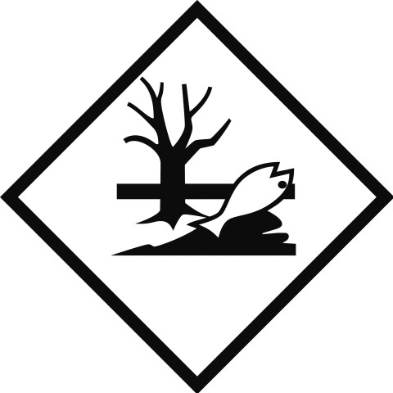

14.6. Special precautions for user
EmS F-A, S-F
ADR transport category 3
Emergency Action Code •3Z
Hazard Identification Number 90
(ADR/RID)
Tunnel restriction code (-)

14.7. Transport in bulk according to Annex II of MARPOL and the IBC Code
Transport in bulk according to Not applicable. Annex II of MARPOL 73/78 and the IBC Code
SECTION 15: Regulatory information

15.1. Safety, health and environmental regulations/legislation specific for the substance or mixture
National regulations | Control of Substances Hazardous to Health Regulations 2002 (as amended). EH40/2005 Workplace exposure limits.
EU legislation | Commission Regulation (EU) No 2015/830 of 28 May 2015.  Regulation (EC) No 1272/2008 of the European Parliament and of the Council of 16  December 2008 on classification, labelling and packaging of substances and mixtures (as amended).  Regulation (EC) No 1907/2006 of the European Parliament and of the Council of 18 December 2006 concerning the Registration, Evaluation, Authorisation and Restriction of Chemicals (REACH) (as amended).  Commission Directive 2000/39/EC of 8 June 2000 establishing a first list of indicative occupational exposure limit values in implementation of Council Directive 98/24/EC on the protection of the health and safety of workers from the risks related to chemical agents at work (as amended).  Regulation (EC) No 648/2004 of the European Parliament and of the Council of 31 March 2004 on detergents (as amended).

15.2. Chemical safety assessment
No chemical safety assessment has been carried out.
SECTION 16: Other information
Abbreviations and acronyms used in the safety data sheet | PBT: Persistent, Bioaccumulative and Toxic substance.  vPvB: Very Persistent and Very Bioaccumulative.
Revision | 1
SDS number | 24283
Hazard statements in full | H301 Toxic if swallowed.  H302 Harmful if swallowed.  H314 Causes severe skin burns and eye damage.  H315 Causes skin irritation.  H318 Causes serious eye damage.  H373 May cause damage to organs through prolonged or repeated exposure.  H400 Very toxic to aquatic life.  H410 Very toxic to aquatic life with long lasting effects.  H411 Toxic to aquatic life with long lasting effects.
DIRECTIONS FOR USE
PRODUCT LOGO

