
Product:
Version: 3

Section 1. Identification of the substance or the mixture and of the supplier
1.1 Product Identifier
Product identifier: STAINLESS STEEL CLEANER (ALKALINE) (Contains:Alcohols, C12-13 - branched and linear, ethoxylated, SODIUM HYDROXIDE, Tetrasodium Ethylendiamine Tetraacetate)
Other identifiers: None
1.2 Relevant identified uses of the substance of mixture and uses advised against
Product uses: Stainless Steel Cleaner
1.3 Details of the supplier of the safety data sheet
Company name:  Company address:  Contact:  E-Mail address: | Parc Supplies Ltd  2 Whitehall Point  Whitehall Road  LS124RZ  info@parcglobal.com
Company phone: | 0113 220 4080
1.4 Emergency telephone number
Emergency phone: 0113 220 4080 - Mon-Fri 7.30am-4.30pm

Section 2. Hazards identification
2.1 Classification of the substance or mixture

Class and category of danger:
2.2 Label elements
Signal word:
Hazard statements:
Supplemental Information:
Classification under Regulation (EC) No 1272/2008
Skin Corrosion / Irritation Category 2
Eye Damage / Irritation Category 1 H315, Causes skin irritation.
H318, Causes serious eye damage.
Classification under Regulation (EC) No 1272/2008
Danger
H315, Causes skin irritation.
H318, Causes serious eye damage.
None

Version: 3
Precautionary P264, Wash hands and other contacted skin thoroughly after handling.
statements: P280, Wear protective gloves/eye protection/face protection.
P302/352, IF ON SKIN: Wash with plenty of soap and water.
P305/351/338, IF IN EYES: Rinse cautiously with water for several minutes. Remove contact
lenses, if present and easy to do. Continue rinsing.
P310, Immediately call a POISON CENTER or doctor/physician.
P332/313, If skin irritation occurs: Get medical advice/attention.
P362, Take off contaminated clothing and wash before reuse.
Pictograms: 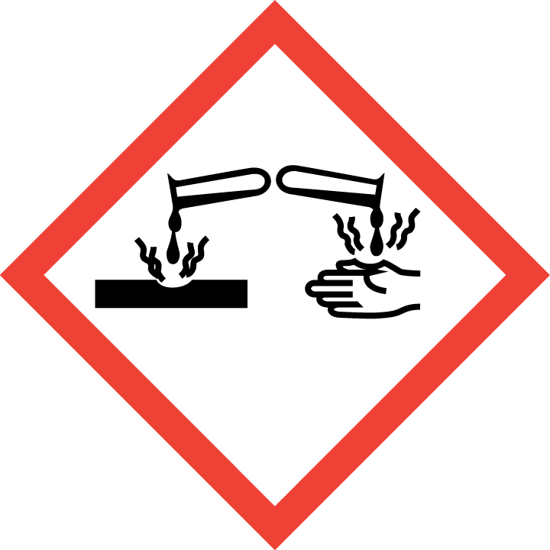
2.3 Other hazards
Other hazards: None
Section 3. Composition / information on ingredients
3.2 Mixtures
Contains:
REACH Registration Classification for
Name CAS EC %
No. (CLP) 1272/2008
Tetrasodium
Acute Tox. 4-Eye Dam.
Ethylendiamine 64-02-8 200-573-9 01-2119486762-22-XXXX 5-<10%
1;H302-H318,-
Tetraacetate
SODIUM HYDROXIDE 001310-73-2 215-185-5 01-2119457892-27-XXXX 1-<5% Skin Corr. 1A;H314,-
Alcohols, C12-13 - Acute Tox. 4-Eye Dam.
160901-19-9, 931-954-4, branched and linear, POLYMER - EXEMPT 0.1-<1% 1-Aquatic Chronic 3;
68439-46-3 614-482-0
ethoxylated H302-H318-H412,-
Substances with Community workplace exposure limits:
Not Applicable
Substances that are persistent, bioaccumulative and toxic or very persistent and very bioaccumulative, greater than 0.1%: Not Applicable

Section 4. First-aid measures
4.1 Description of first aid measures
Inhalation: Remove from exposure site to fresh air, keep at rest, and obtain medical attention.
Version: 3
Eye exposure: | IF IN EYES: Rinse cautiously with water for several minutes. Remove contact lenses, if present and easy to do. Continue rinsing.
Skin exposure: | IF ON SKIN: Wash with plenty of soap and water.
Ingestion: | Rinse mouth with water and obtain medical attention.
4.2 Most important symptoms and effects, both acute and delayed
Causes skin irritation.
Causes serious eye damage.
4.3 Indication of any immediate medical attention and special treatment needed None expected, see Section 4.1 for further information.

SECTION 5: Firefighting measures
5.1 Extinguishing media
Suitable media: Carbon dioxide, Dry chemical, Foam.
5.2 Special hazards arising from the substance or mixture
In case of fire, may be liberated: Carbon monoxide, Unidentified organic compounds.
5.3 Advice for fire fighters:
In case of insufficient ventilation, wear suitable respiratory equipment.

Section 6. Accidental release measures
6.1 Personal precautions, protective equipment and emergency procedures:
Avoid inhalation. Avoid contact with skin and eyes. See protective measures under Section 7 and 8.
6.2 Environmental precautions:
Keep away from drains, surface and ground water, and soil.
6.3 Methods and material for containment and cleaning up:
Remove ignition sources. Provide adequate ventilation. Avoid excessive inhalation of vapours. Contain spillage immediately by use of sand or inert powder. Dispose of according to local regulations.
6.4 Reference to other sections:
Also refer to sections 8 and 13.
Version: 3

Section 7. Handling and storage
7.1 Precautions for safe handling:
Keep away from heat, sparks, open flames and hot surfaces. - No smoking. Use personal protective equipment as required. Use in accordance with good manufacturing and industrial hygiene practices. Use in areas with adequate ventilation Do not eat, drink or smoke when using this product.
7.2 Conditions for safe storage, including any incompatibilities:
Store in a well-ventilated place. Keep container tightly closed. Keep cool. Ground/bond container and receiving equipment. Use explosion-proof electrical, ventilating and lighting equipment. Use only non-sparking tools. Take precautionary measures against static discharge.
7.3 Specific end use(s):
Stainless Steel Cleaner: Use in accordance with good manufacturing and industrial hygiene practices.

Section 8. Exposure controls/personal protection
8.1 Control parameters
Workplace exposure limits: | Not Applicable
8.2 Exposure Controls
Eye / Skin Protection
Wear protective gloves/eye protection/face protection
Respiratory Protection
Under normal conditions of use and where adequate ventilation is available to prevent build up of excessive vapour, this material should not require special engineering controls. However, in conditions of high or prolonged use, or high temperature or other conditions which increase exposure, the following engineering controls can be used to minimise exposure to personnel: a) Increase ventilation of the area with local exhaust ventilation. b) Personnel can use an approved, appropriately fitted respirator with organic vapour cartridge or canisters and particulate filters. c) Use closed systems for transferring and processing this material. Also refer to Sections 2 and 7.

Section 9. Physical and chemical properties
9.1 Information on basic physical and chemical properties
Appearance: | Not determined
Odour: | Not determined
Odour threshold: | Not determined
pH: | Not determined
Melting point / freezing point: | Not determined
Initial boiling point / range: | Not determined
Flash point: | > 61 °C
Evaporation rate: | Not determined
Version: 3
Flammability (solid, gas): Not determined
Upper/lower flammability or explosive limits: Product does not present an explosion hazard
Vapour pressure: Not determined Vapour density: Not determined Relative density: Not determined Solubility(ies): Not determined
Partition coefficient: n-octanol/water: Not determined
Auto-ignition temperature: Not determined
Decomposition temperature: Not determined
Viscosity: Not determined
Explosive properties: Not expected
Oxidising properties: Not expected
9.2 Other information: None available

Section 10. Stability and reactivity
10.1 Reactivity:
Presents no significant reactivity hazard, by itself or in contact with water.
10.2 Chemical stability:
Good stability under normal storage conditions.
10.3 Possibility of hazardous reactions:
Not expected under normal conditions of use.
10.4 Conditions to avoid: Avoid extreme heat.
10.5 Incompatible materials:
Avoid contact with strong acids, alkalis or oxidising agents.
10.6 Hazardous decomposition products: Not expected.

Section 11. Toxicological information
11.1 Information on toxicological effects
This mixture has not been tested as a whole for health effects. The health effects have been calculated using the methods outlined in Regulation (EC) No 1272/2008 (CLP).
Acute Toxicity: Based on available data the classification criteria are not met.
Acute Toxicity Oral >5000
Acute Toxicity Dermal Not Applicable
Acute Toxicity Inhalation Not Available
Skin corrosion/irritation: Skin Corrosion / Irritation Category 2
Version: 3
Serious eye damage/irritation: | Eye Damage / Irritation Category 1
Respiratory or skin sensitisation: | Based on available data the classification criteria are not met.
Germ cell mutagenicity: | Based on available data the classification criteria are not met.
Carcinogenicity: | Based on available data the classification criteria are not met.
Reproductive toxicity: | Based on available data the classification criteria are not met.
STOT-single exposure: | Based on available data the classification criteria are not met.
STOT-repeated exposure: | Based on available data the classification criteria are not met.
Aspiration hazard: | Based on available data the classification criteria are not met.
Information about hazardous ingredients in the mixture
LC50
Route
Tetrasodium
Ethylendiamine
Tetraacetate
64-02-8
200-573-9
Not available
Not
available
500
Not available
Ingredient
CAS
LD50/ATE Oral
LD50/ATE
Dermal
LC50/ATE
Inhalation
EC
Refer to Sections 2 and 3 for additional information.

Section 12. Ecological information
12.1 Toxicity: Not available
12.2 Persistence and degradability: Not available
12.3 Bioaccumulative potential: Not available 12.4 Mobility in soil: Not available
12.5 Results of PBT and vPvB assessment:
This substance does not meet the PBT/vPvB criteria of REACH, annex XIII.
12.6 Other adverse effects: Not available

Section 13. Disposal considerations
13.1 Waste treatment methods:
Dispose of in accordance with local regulations. Avoid disposing into drainage systems and into the environment. Empty containers should be taken to an approved waste handling site for recycling or disposal.

Section 14. Transport information
14.1 UN number: | Not classified
14.2 UN Proper Shipping Name: | -
14.3 Transport hazard class(es): | Not classified
Sub Risk: | Not classified
14.4. Packing Group: | Not classified
14.5 Environmental hazards: | Not environmentally hazardous for transport
14.6 Special precautions for user: | None additional
Version: 3
14.7 Transport in bulk according to Annex II of MARPOL73/78 and the IBC Code: Not classified

Section 15. Regulatory information
15.1 Safety, health and environmental regulations/legislation specific for the substance or mixture
Water Hazard Class (WGK): 1
15.2 Chemical Safety Assessment
A Chemical Safety Assessment has not been carried out for this product.

Section 16. Other information
Concentration % Limits: | SCI 2=48.52% EDI 1=38.53% EDI 2=11.97%
Total Fractional Values: | SCI 2=2.06 EDI 1=2.60 EDI 2=8.35
Key to revisions:
Concentration % Limits
Product identifier
SECTION 3: Composition/information on ingredients
Total Fractional Values Key to abbreviations:
Abbreviation | Meaning
Acute Tox. 4 | Acute Toxicity - Oral Category 4
Aquatic Chronic 3 | Hazardous to the Aquatic Environment - Long-term Hazard Category 3
Eye Dam. 1 | Eye Damage / Irritation Category 1
H302 | Harmful if swallowed.
H314 | Causes severe skin burns and eye damage.
H318 | Causes serious eye damage.
H412 | Harmful to aquatic life with long lasting effects.
P260 | Do not breathe vapour or dust.
P264 | Wash hands and other contacted skin thoroughly after handling.
P270 | Do not eat, drink or smoke when using this product.
P273 | Avoid release to the environment.
P280 | Wear protective gloves/eye protection/face protection.
P301/312 | IF SWALLOWED: call a POISON CENTER or doctor/physician if you feel unwell.
P301/330/331 | If swallowed: Rinse mouth. Do not induce vomiting.
P303/361/353 | IF ON SKIN (or hair): Remove/take off immediately all contaminated clothing. Rinse skin with water/shower.
P304/340 | IF INHALED: Remove victim to fresh air and keep at rest in a position comfortable for breathing.
P305/351/338 | IF IN EYES: Rinse cautiously with water for several minutes. Remove contact lenses, if present and easy to do. Continue rinsing.
P310 | Immediately call a POISON CENTER or doctor/physician.
P330 | Rinse mouth.
Version: 3
P363 | Wash contaminated clothing before reuse.
P405 | Store locked up.
P501 | Dispose of contents/container to approved disposal site, in accordance with local regulations.
Skin Corr. 1A | Skin Corrosion / Irritation Category 1A
The information in this safety data sheet is to the best of our knowledge true and accurate but all data, instructions, recommendations and/or suggestions are made without guarantee.

